Gate Pass missing mandatory fields

/v1/truck-visits/get-visit doesn't return failReason even there's validation error.

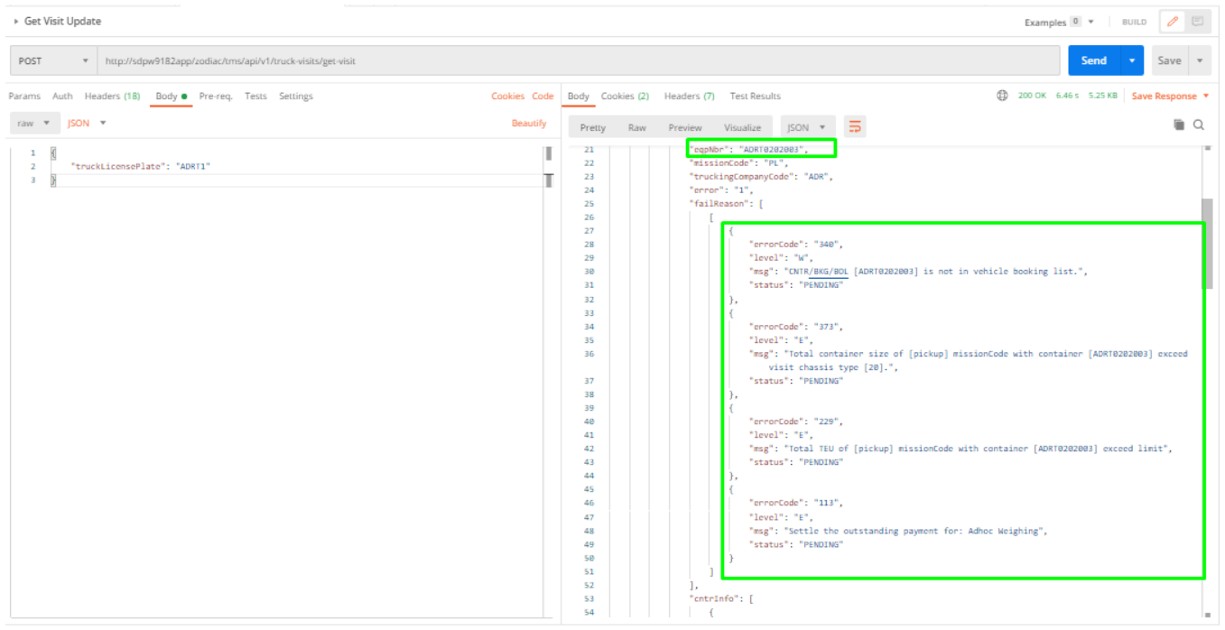

CFS - Cargo Mobile Issue

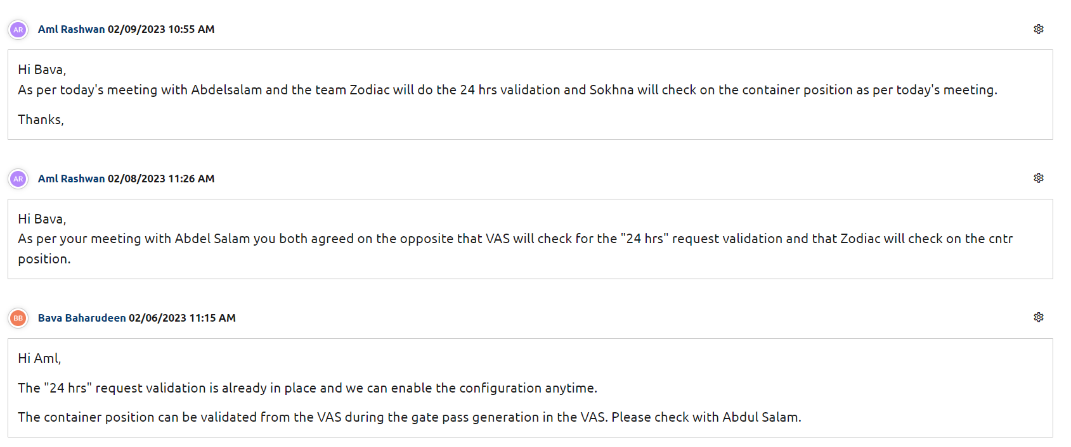

Validations (Load List)

Steps to test  
1. Create a Vessel Visit  
2. Receive some export containers for the same Vessel Visit  
3. Mark one export container as Back to Town (Change the shipping status to "BT")  
4. Create a Load List including the container which is changed the shipping status = BT  
5. upload the load list in VAS

Expected result BT container should not update - Error message "BT container is not allowed to Release"

-Shan

/v1/bol/{bolNbr}@{vesselVisit}/update doesn't update stuffing request

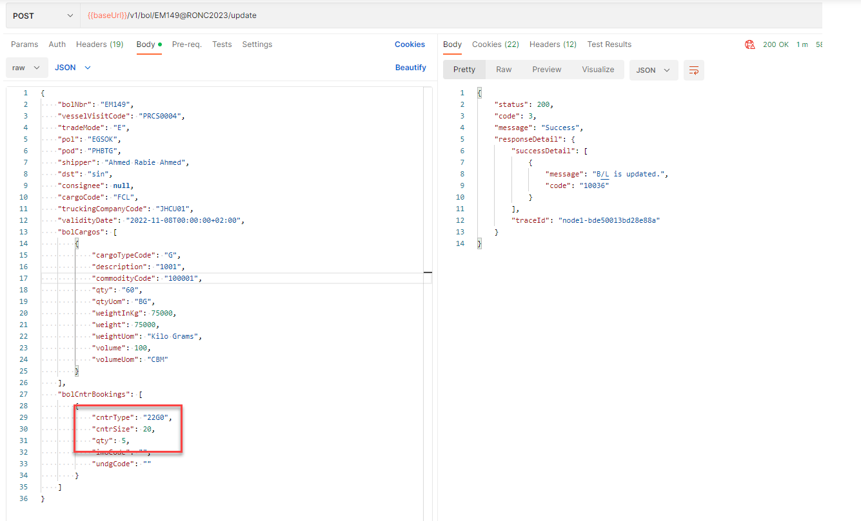

SOK BE- Cancellation of Gate Visit and Appointment

